Verified Token functionality

Here you will find normal usage scenario for proposed Verified Token Standard whose main intended purpose is to verify ERC20 token transfers basing on the whitelists.

Contracts related to Verified Token are:

* Verified Token itself
* Verified Token Controller – to manage process of verification
* Verified Token Registry – to manage whitelists.

# Verified Token

Extension to ERC20 standard. It doesn’t propose any extra features and just upgrade standard transfer() and transferFrom() functions by adding check if the receiver is enlisted in the whitelists, assigned by Token Issuer.

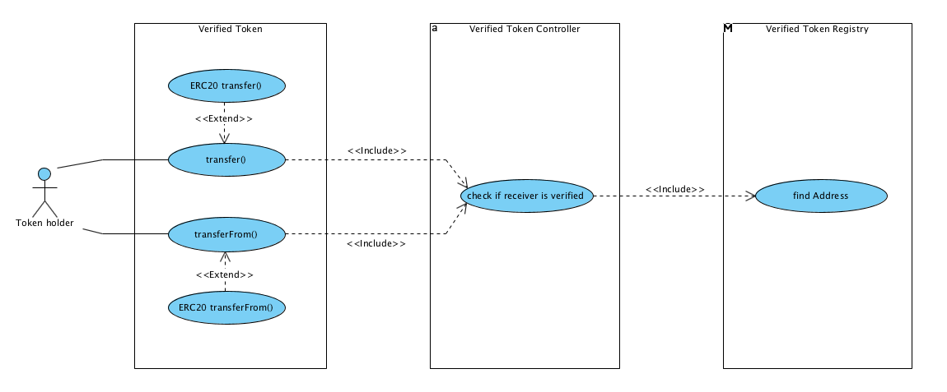

If Token Controller’s isVerified() function confirms that receiver address is verified, then standard ERC20 functions will be called.

isVerified() use verifications parameters set by Token Issuer and, in turn, call Verify Token Registry to check if receiver address is whitelisted and has required characteristics.

# Verified Token Controller

By deploying contract, Issuer setup the list of registries which will be used to check transfers. Issuer can alter this list later, as well as number of required confirmations (how many registries should confirm they have the receiver address in their records).

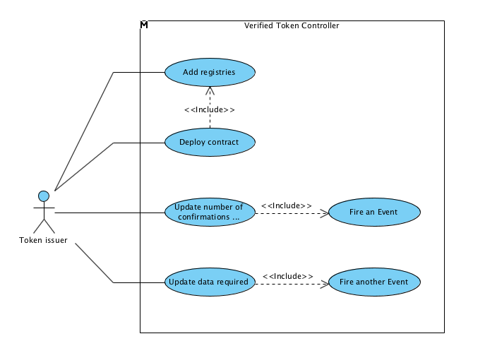

Token issuer can specify data required for successful transfer in the form of key => value pairs, e.g.:

* “Age group” => “18+”
* “Receiver country” => “New Zealand”
* “KYC” => “true”
* “ID type” => “Passport”

Each address will be checked for enlisting in registries records with this pair.

# Verified Token Registry

Registries keep records of addresses and associated pairs:

* 0x123… => [ “Age group” => “18+” ]
* 0x123… => [ “Receiver country” => “New Zealand” ]
* 0x123… => [ “KYC” => “true” ]
* 0x123… => [ “ID type” => “Passport” ]

Registry owner can add, delete or update records.

Anyone able to call findAddress() function with address and required pair as a parameters. The function returns true if address is enlisted with required pair, which means that address is verified.

This function is also used by Verified Token Controller, for same purpose.

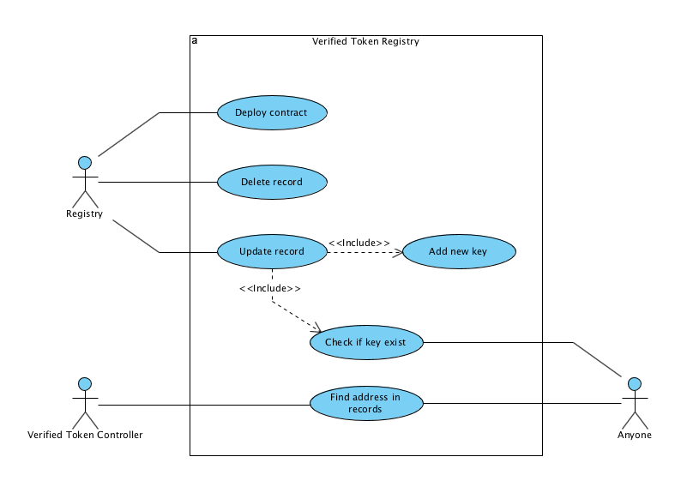

Registry has another public function – isExist(), that check if key (for key => value pairs) is exist in the records of this registry.